# ScotELAs Mentoring Scheme for Professional Development Handbook

ScotELAs Mentoring Scheme for Professional Development 1

Introduction 2

Defining mentoring 3

Benefits of mentoring 4

The ScotELAs Mentoring Scheme for Professional Development 5

Role-focused mentoring 6

Expertise-focused mentoring 8

Quality control procedures and documentation 9

References 10

Appendix 1: The Basis of a good Mentoring Partnership 11

Appendix 2: The Mentoring Agreement 13

Appendix 3: Building the Mentoring Partnership 16

Appendix 4: Guidance to Prepare Reflective Accounts 19

## Introduction

Learning development attracts highly skilled individuals from wide ranging professional qualifications and academic backgrounds including, for example, education, English literature, linguistics, humanities and arts, science and social sciences (Canton, 2016).This diversity provides a rich knowledge source and potential for cross-fertilisation of skills and knowledge among those operating within the field. However, due to their varying and often remote positions within HEIs, learning development roles often don’t fit into traditional academic career development pathways and harnessing professional development opportunities can be a challenge.

To address this challenge, ScotELAs has developed a mentoring scheme which provides the opportunity for learning developers to gain recognition for their participation and associated learning. We believe that given the supportive, empowering nature of their work, coupled with their diverse professional backgrounds, learning developers are ideally suited to mentoring roles, and we see the great diversity of experience in the profession as an ideal background for developing and enhancing skills.

Grounded in reflective practice, the scheme recognises the potential for mentoring to embed lasting enhancements in professional development (Rhodes & Beneicke, 2002) and provides officially recognised pathways to enhance participants’ professional profiles. These are conceptualised under a broad definition of mentoring; mentors as experts in learning development and mentors as peer educators in specific areas of academic practice. The pathways therefore offer developmental opportunities for all members of the ScotELAs community, regardless of expertise or status.

This handbook is written for both mentors and mentees and outlines:

* how the scheme conceptualises mentoring
* how it can benefit participants
* what the expectations and roles of mentors and mentees are
* how the mentoring pathways operate.

Supplementary documents are also included in the appendices to support participants in their participation and in gaining ScotELAs recognition.

If you have any feedback or questions, please feel free to contact us!

[Jane.McKay@gcu.ac.uk](mailto:Jane.McKay@gcu.ac.uk) or [ursula.canton@gcu.ac.uk](mailto:ursula.canton@gcu.ac.uk)

## Defining mentoring

The education literature identifies different types of mentoring, including mentoring students or trainees to achieve professional qualifications, or teaching staff in their transitions to new institutions. Various definitions and practices thus exist, ranging from, ‘peer pal’, where individuals have the same status and provide mutual support, to more traditional, enduring mentor-mentee relationships, where the mentor assumes the roles of advocate and teacher (Shapiro, 1978). Embracing themes of reflection, sharing and helping in in non-judgemental and non-hierarchical ways, ScotELAs’ Mentoring Scheme considers mentoring as a process of mutual learning for both mentors and mentees who are peers in the learning development field. In addition, mentoring is viewed as encompassing peer relationships of varied intensity and duration to suit the needs of those seeking to advance their professional development. Reflecting this broad perspective, and the scheme’s inclusion of a wide range of mentoring practises, the following definition is adopted:

**A mentor is anyone who provides guidance, support, knowledge, and opportunities for whatever period the mentor and protégé deem this help to be necessary.**

(Burlew, 1991, p. 214).

With this definition in mind, Appendix 1 provides further information on the role of the mentor and expectations / effective behaviours of mentees and mentors.

## Benefits of mentoring

The benefits of mentoring are well documented. Within the business literature, research has identified learning through mentoring as the leading source of individual performance in the workplace (Corporate Leadership Council, 2005). Elsewhere, education research has documented the value of peer relationships in allowing mentees to experience a ‘feel equal’ factor (Blackwell & McLean, 1996) and enhanced confidence and self-esteem (Lieberman & Miller, 2000). Outcomes such as these, as Smith (1990) suggests, are made possible by the absence of hierarchies which facilitates mutual support and the collaboration necessary for effective learning. As indicated below, the benefits of mentoring are not exclusive to mentees; mentors have much to gain too, including the enhancement of interpersonal, leadership and pedagogic skills that can be applied to other contexts (Morton, 2003).

Additional benefits for mentors and mentees are summarised in Table 1:

|  |  |
| --- | --- |
| Mentee benefits | Mentor benefits |
| Accelerates professional development | Develops leadership skills |
| Expands mentee’s professional network | Enhances interpersonal skills |
| Increases job satisfaction and effectiveness | Provides sense of satisfaction associated with ‘giving back’ |
| Increases perspective and knowledge | Enhances context-specific teaching skills |
| Increases self-awareness | Increases self-awareness |

Table 1: Summary of benefits to mentees and mentors of the mentoring process

## The ScotELAs Mentoring Scheme for Professional Development

In order to provide developmental opportunities for learning developers at all stages of their careers, two pathways have been developed:

* ‘role-focused’ for early career learning developers and
* ‘expertise-focused’ for those at any stage of their career who wish to develop skills in a particular area of practice.

As is recognised in many educational professional standards frameworks and accreditation programmes, reflective practice is key to determining the extent to which developmental gains are made. Here mentors can go beyond simple mechanistic direction and aid the mentee’s reflection on practice (e.g. Allan, 2007; Jones, 2012; Rhodes & Beneicke, 2002; Sempowicz, 2012). Indeed, without this facilitated reflection, consolidated learning may not occur (Thompson, 2001). Reflective practice is thus viewed as a core element of the ScotELAs Mentoring Scheme and is embedded in the pathways and quality control requirements described below.

## Role-focused mentoring

The scheme’s definition of role-focused mentoring aligns with traditional notions of mentoring where a more experienced learning developer works with a less experienced peer for as long as the relationship continues to be mutually beneficial. Mentor and mentee can agree specific areas of the role as a particular focus, but the overall aim is to help the early career mentee to develop expertise and best practice in learning development by supporting learning about the role, as well as reflection on their own performance, and offering feedback on this where appropriate and desired.

In order to attain ScotELAs recognition, however, a minimum level of quality control is necessary. Firstly, participants must engage with the scheme for a minimum of 6 months and secondly, some formal documentation to record evaluative and reflective processes must be completed. More details on this are provided below and in the appendices.

**Step 1: Identifying a mentor**

Given that successful mentoring is dependent on a strong, trusting relationship between two individuals (Byington, 2010), it is important that mentees have freedom to select who they wish to work with. As a starting point, prospective mentees are directed to the ScotELAs website where profiles of mentors are located (http://www.scotELAs.org/membership-profiles). Profiles provide information on the mentor’s specific skills, experience and what they feel they can offer to the mentoring process. After identifying a possible mentor, mentees should initiate contact and arrange to meet, ideally in a face-to-face or verbal format. Subsequently, a decision should be made by both mentor and mentee as to whether they will embark on a mentoring partnership. It is especially important that both mentor and mentee are comfortable with each other and perfectly acceptable to decide not to pursue the partnership. Once a mentoring partnership has been agreed, participants should complete the ScotELAs Mentoring Agreement (Appendix 3).

**Step 2: Developing the mentoring relationship and working together**

Following agreement of the mentoring partnership the mentor and mentee should begin to build their relationship. This will involve establishing goals and expectations, defining an initial action plan for the mentee’s professional development and agreeing on the frequency of subsequent meetings. Whilst frequency of meetings will depend on geographical locations and developmental goals, it is recommended that no more than 2 months should pass between them to ensure the continuity of the process. Initial meetings are critical to building a strong basis for the mentoring partnership and Appendix 2 provides resources to facilitate this process.

**Step 3: Reviewing goals, reflection and continued action planning**

The time committed to this stage will depend on the mentee’s developmental goals and the extent to which the mentee and mentor continue to derive benefits from the partnership. During this stage the mentor should facilitate the mentee’s reflections on learning so far and what still needs to be done. A revised set of goals and action plans can then be collaboratively developed.

**Step 4: Evaluation and final reflection**

When both mentor and mentee are satisfied that goals have been met and all benefits of the mentoring partnership have been reaped, both mentor and mentee should engage in some final reflection and evaluation of the mentoring process. Guidance for completing this stage, including the submission of reflective accounts, is provided in Appendix 4. Reflective accounts will be stored in a strictly confidential, password-protected online format. Upon receipt of reflective accounts and evaluation forms, participants will have completed the scheme and will receive ScotELAs recognition in the form of a certificate that identifies their role and the type of mentorship they participated in.

Figure 2 provides a summary of the pathway.

**Reflective practice**

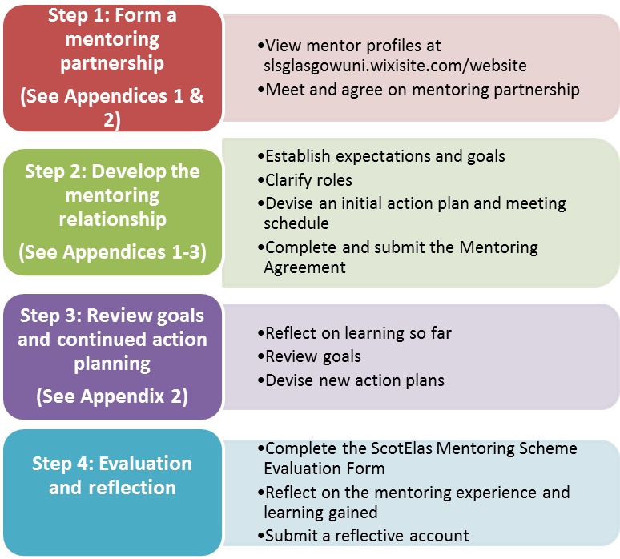

Figure 2: Summary of the role-focused mentoring process

## Expertise-focused mentoring

Expertise-focused mentoring, as defined by ScotELAs, is a form of mentoring that draws upon the related ideas of coaching (Downey, 2001) and peer networking (Rhodes & Beneicke, 2002) where, put simply, one colleague supports the learning and development of another. As the name implies, in expertise-focused mentoring the mentor has expertise in a specific area of practice and provides professional development to a peer who wishes to develop their knowledge or skills in that area. In contrast to role-focused mentoring, which involves an extended mentor-mentee relationship, expertise-focused coaching is likely to span over a shorter timeframe and the mentor will not necessarily be a more experienced learning developer. This mentoring pathway taps into the diverse professional and academic backgrounds of the ScotELAs community and in doing so, provides a forum for sharing knowledge and skills to develop an expertise-based practice across the sector. Developmental areas might include, for example, research skills, EAP, pedagogies for specific discipline contexts, digital literacy skills and working with specific student groups. ScotELAs members are encouraged to consult the mentor profiles available on the website (http://slsglasgowuni.wixsite.com/website) to identify professional development contexts of interest and a potential mentor.

As with role-focused mentoring, reflective practice is embedded in expertise-focused mentoring and there are benefits for both mentor and mentee; whilst the mentee develops professional expertise, the mentor develops skills in leading and delivering CPD. In order to achieve recognition from the scheme, participants must complete and submit the documentation specified in the appendices, including a reflective account. Figure 3 provides a summary of the pathway.

**Reflective practice**

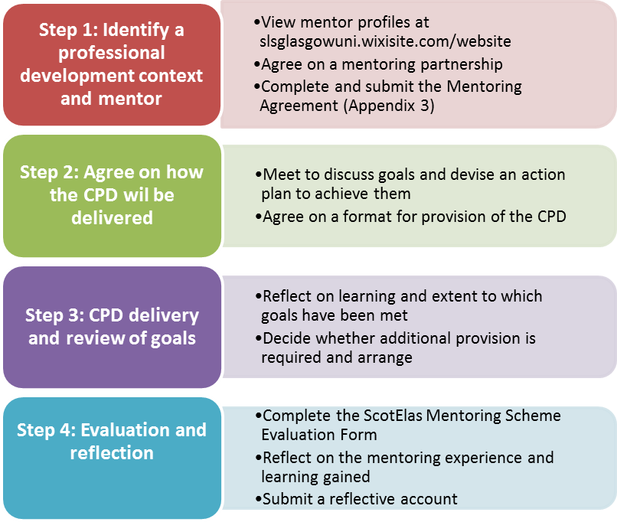

Figure 3: Summary of the expertise-focused mentoring process

## Quality control procedures and documentation

One of the central aims of this project is to allow ScotELAs members gain recognition for the mentorship they provide and the learning they achieve through mentorship. In order to justify a formal recognition, a minimum level of quality control is necessary.

The suggested format aims at avoiding additional work. Instead, it asks participants to demonstrate their engagement in the process by sharing an initial agreement between mentor and mentee, as well as their reflection on the mentoring process. In other words, the documents that need to be submitted can both support the mentoring process and document it. In addition, the proposed framework is deliberately wide, so that mentors and mentees can make them as relevant and meaningful to their own collaboration as possible, while demonstrating to ScotELAs that the engagement reflected in them is worthy of recognition.

These documents include:

* An initial mentoring agreement, based on the framework provided in Appendix 3. This is to be developed collaboratively by mentor and mentee and means they are registered in the ScotELAs mentorship database.
* Two short individual reflections, which can be submitted at the end or during the mentorship process, whenever is more useful for the participants.

The format (written, video, audio) and length can be determined by each participant according to personal preference, provided they focus on any of the questions outlined in Appendix 4.

* A short evaluation (Lickert scales, optional open questions) of the degree to which you have kept your mentoring agreement. This is to be filled in separately, but sharing your responses with your mentor / mentee is a good way of stimulating reflection on the process, so this is definitely encouraged.

## References

Allan, P. (2007). The benefits and impacts of a coaching and mentoring programme for teaching staff in secondary school. *International Journal of Evidence Based Coaching and Mentoring,* 5(2), pp. 12-21.

Blackwell, R. and McLean, M. (1996). “Formal pupil or informal peer?” In Fullerton, H. (Ed.), Facets of Mentoring in HE, SEDA paper 94.

Burlew, L.D. (1991). Multiple mentor model: a conceptual framework. *Journal of Career Development*, 17 (3), pp. 213-21.

Byington, T.(2010). Keys to successful mentoring relationships. *Journal of Extension*, 48 (6).

Canton, U. (2016). *Survey: Writing Practitioners’ Backgrounds*. Unpublished Material.

Clutterbuck, D. (1991), Everyone Needs a Mentor. IPM: London.

Corporate Leadership Council. (2010). “Improving your mentoring relationship.” The Corporate Executive Board Company: London.

Jones, J. (2012). An analysis of learning outcomes within formal mentoring relationships. *International Journal of Evidence Based Coaching and Mentoring*, 10(1), pp. 57-73.

Lieberman, A. & Miller, L. (2000). “Teaching and Teacher Development: a new synthesis for a new century.” In R. S. Brandt (Ed.) Education in a New Era. ASCD: Virginia.

Morton, A. (2003). “Mentoring – is it worth it?” Good practice series number 34. The Association of University Administrators. Manchester.

Rhodes, C. & Beneicke, S. (2002) Coaching, mentoring and peer-networking: challenges for the management of teacher professional development in schools, *Journal of In-Service Education*, 28(2), 297-310.

Sempowicz, T. (2012). Mentoring pre-service teachers’ reflective practices towards producing teaching outcomes. *International journal of evidence based coaching and mentoring*, pp. 10 (2), 52-64.

Shapiro, E.C., Hazeltine, F. & Rowe, M. (1978). Moving up: role models, mentors and patron systems. *Sloan Management Review*, 78 (19), pp. 51-58.

Smith, B. (1990). Mutual mentoring projects. *Journal of Management Development*, 9 (1), p. 51-57.

Thompson, M. (2001). “Towards Professional Learning Communities?” In D. Gleeson and C. Husbands (Eds), The Performing School: Teaching and Learning in a Performance Culture: RoutledgeFalmer: London

## Appendix 1: The Basis of a good Mentoring Partnership

**The Role of the Mentor**

A number of career-orientated and psychosocial mentor descriptions are associated with the mentor role. These include: advocate, collaborator, coach, networker, facilitator, and challenger (Clutterbuck, 1991). Applying these to the context of learning development, the role of the mentor might include the following:

* **Facilitating acculturation to the learning development** role by passing on knowledge within the field and philosophies that underpin practice (e.g. academic literacies, enhancement-led approaches, inclusive, equitable support)
* **Sharing examples of good practice** (e.g. pedagogical approaches, ways of working with specific student groups)
* **Promoting exploration, reflection and self-awareness** (e.g. strengths and weaknesses of teaching skills and psychological attributes such as confidence and motivation)
* **Advising on how to deal with specific challenges** (e.g. student dependency, perceptions of stigma, collaborating with subject discipline staff)
* Serving as a **sounding board** for ideas
* **Supporting the development of specific skills**

**Expectations of mentees and mentors: Effective behaviours**

Just as learning developers assist students in taking responsibility for their own learning, mentees must accept that learning rests with them. Optimising the mentoring experience requires mentees to be active learners, as reflected in the expected behaviours summarised in Table 2. It is also important to ensure clear expectations and ensure that both mentor and mentee recognise that it is not the mentor’s role to solve problems, take responsibility for the mentee, tell the mentee what to do, or to fight the mentee’s battles. Rather, as indicated below, the mentor should ensure a safe environment in which to challenge, give direction and empower.

|  |  |
| --- | --- |
| Effective mentee behaviours | Effective mentor behaviours |
| Demonstrate a genuine interest in being supported by the mentor | Support the mentee, acting as a safety net and ensuring a safe environment to take risks |
| Identify professional development needs and goals | Act as a sounding board and facilitator |
| Demonstrate a desire to develop in an identified area | Provide structure and direction based on observations during mentoring meetings |
| Find ways of achieving objectives and contribute ideas for solving problems | Empower the mentee to deal with any problems and pursue goals independently |
| Be willing to discuss strengths and weaknesses | Help the mentee identify any competence gaps |
| Commit the necessary time and energy and complete any preparation for mentoring meetings | Provide opportunities for the mentor to reflect on and enhance practices, e.g. by scaffolding teaching experiences |
| Take responsibility for scheduling meetings with the mentor | Identify and facilitate developmental and networking opportunities |
| Follow up on action items identified during mentoring meetings | Provide empathy and understanding |
| Maintain confidentiality of all mentoring conversations | Provide candid feedback to the mentee about perceived strengths and developmental needs. |
| Provide feedback to evaluate and develop the mentoring process | Maintain confidentiality of all mentoring conversations |

Effective behaviours of the mentee and mentor (Adapted from Corporate Leadership Council Mentee Handbook, 2010)

## Appendix 2: Building the Mentoring partnership

**Building the mentoring partnership**

Clarifying roles, responsibilities and expectations contributes strongly to the development of the mentoring partnership and should be jointly discussed when completing the ScotELAs Mentoring Contract. To support this process, participants are directed to the definitions and behaviours discussed in this handbook. Additionally, the documentation below is designed to assist with: identifying hopes and expectations of the mentoring relationship; guiding the first conversation; and defining goals and action plans.

**Role-focused mentoring: Mentee pre-meeting thought document**

|  |  |
| --- | --- |
| Questions to consider | Notes |
| What do you hope to gain from the mentoring relationship? |  |
| What role do you expect your mentor to play? |  |
| Are there any ground rules you’d like to set (e.g.  confidentiality, openness) |  |
| What do you see as your strengths as a teacher /  learning developer? |  |
| What do you see as your weaknesses as a teacher / learning developer? |  |
| What are your short and long-term learning goals? |  |
| How would you like to go about achieving your learning goals? |  |
| Are there any topics of urgent interest? |  |
| What would you like the regular meeting schedule to be (length, time, frequency)? |  |
| When will you aim to reflect on the mentoring experience and how will you record this? |  |

Adapted from Corporate Leadership Council Mentee Handbook, 2010

**Role-focused mentoring: Questions to guide the first mentoring conversation**

|  |
| --- |
| * What is your educational and professional background? What attracted you to learning development? |
| * What do you see as your greatest strengths and weaknesses as a teacher / learning developer? |
| * What do you find challenging / rewarding about your role? |
| * What are your short-term and long-term learning goals? |
| * What are your interests outside of work? |
| * What do you see as my role as your mentor? |
| * What ground rules shall we set? |
| * Are there any topics of urgent interest? |
| * What topics do you want to cover in our conversations? |
| * What do you hope to gain from this partnership? |
| * How shall we communicate between meetings? |

Adapted from Corporate Leadership Council Mentee Handbook, 2010

**Role-focused mentoring: Building action plans**

Mentors and mentees should work collaboratively on building an action plan to achieve the established objectives. Action plans could include mentee activities such as observing the mentor teaching, attending a developmental session led by the mentor, identifying and attending conferences and other CPD opportunities and mentor activities such as modelling good teaching practice, suggesting CPD and training events, providing opportunities for collaborative project work, and observing the mentor’s practice and providing feedback. The form below can be used to help define goals and develop action plans.

|  |  |  |  |  |  |  |
| --- | --- | --- | --- | --- | --- | --- |
| Mentee name: | | | Mentor name: | | | Date: |
| Learning goals: | | | | | | |
| Objectives | **Mentee actions** | **Mentor actions** | **Support network’s actions** | **Potential barriers** | **Success measures** | **Target completion date** |
|  |  |  |  |  |  |  |
|  |  |  |  |  |  |  |
|  |  |  |  |  |  |  |
|  |  |  |  |  |  |  |
|  |  |  |  |  |  |  |
|  |  |  |  |  |  |  |

Adapted from Corporate Leadership Council Mentee Handbook, 2010

## Appendix 3: The Mentoring Agreement

The mentoring agreement helps you clarify your mutual expectations, so please discuss this with your mentor / mentee and submit a single, shared document [Jane.McKay@gcu.ac.uk](mailto:Jane.McKay@gcu.ac.uk) or Ursula.canton@gcu.ac.uk. By submitting this document, you will also be entered into the ScotELAs database, so this is the first step towards recognition for your mentorship collaboration.

For practical reasons, please send a word processed answer, not a hand-written and scanned one.

Name of the Mentor: Click here to enter text.

Institution: Click here to enter text.

Name of the Mentee: Click here to enter text.

Institution: Click here to enter text.

**Deciding on the focus of mentorship**:

Is your collaboration:

role-focused mentoring (i.e. helping the mentee’s growth in her/his role)?

expertise-focused mentoring (i.e. developing the mentee’s knowledge or ability in a specific aspect of her/his work)?

If it is expertise focused, please detail which specific skill / aspect of work you will focus on:

Click here to enter text.

Please identify at least 3 goals or desirable outcomes of this mentorship process for the mentee:

(e.g. “The mentee will have gained insight into different approaches to group teaching”, or “The mentee will have learned more about qualitative research methodologies from guided reading and discussion of their application with the mentor.”)

Outcome 1: Click here to enter text.

Outcome 2: Click here to enter text.

Outcome 3: Click here to enter text.

Other outcomes: Click here to enter text.

**Roles and Responsibilities**

Please identify the **mentee’s responsibilities**:

(e.g. identify the challenges they want to discuss for each meeting)

You might want to consider:

* the preparation for a session
* their contribution during a session
* the follow-up to a session
* attitudes
* behaviours

Mentee’s responsibilities:

Click here to enter text.

Please identify the **mentor’s responsibilities**:

(e.g. ask further questions about possible solutions, or share relevant experience)

You might want to consider:

* the preparation for a session
* their contribution during a session
* the follow-up to a session
* attitudes
* behaviours

Mentor’s responsibilities:

Click here to enter text.

Please work out any **ground rules** for the **tone of your conversations**:

(e.g. polite criticism is desired, but has to include positive suggestions on how to improve).

You might want to consider:

* Levels of openness
* Levels of evaluation and the way this is offered
* Forms in which difficult questions can / cannot be asked (email? Face to face?)

Ground rules:

Click here to enter text.

Please identify the **logistical ground rules** for your collaboration:

(e.g. “We aim to speak over the phone once in a fortnight”. Or “We communicate by email as and when required. Both aim to respond within a week”.)

You might want to consider:

-how often you communicate

-in which manner (face to face, over the phone, by email)

- where do you meet (if relevant)

-whether you want to define the focus of a meeting beforehand (and how you do this)

-how you identify whether the mentorship is working well for both sides involved?

Logistical ground rules:

Click here to enter text.

## Appendix 4: Guidance to Prepare Reflective Accounts

In order to receive ScotELAs recognition, you need to submit 2 reflective pieces which can be produced (and submitted) at any stage of the mentorship, depending on when reflection is most useful to support your learning. The format can also be chosen to suit your personal preference, as long as ScotELAs can store the documentation in the form of an electronic file (text, audio, video are all fine; 3D objects are not). The guidance below applies to both the role-focused and expertise-focused mentoring pathways.

The following questions can be adapted to your own situation:

**Questions for Mentees**

Describe a step you aim to take for your career development and explain how mentoring has helped you formulate this goal.

Describe how you will use one aspect of your newly gained knowledge for your future work and explain how mentoring has helped you achieve this knowledge.

Identify a strength / weakness that the mentoring process has revealed and plan how you are going to harness / improve on this in the future.

Identify a decision you will need to take and analyse how the mentoring process can help you take it.

**Questions for Mentors**

Identify a new insight into your role that has arisen from the mentoring process and explain what consequences this might have for your future work.

Identify a new question that has arisen from the mentoring process, explain why it is relevant for your work and how you will explore it further in the future.

Identify a strength / weakness that the mentoring process has revealed and plan how you are going to harness / improve on this in the future.

Choose a moment in the mentoring process that required your leadership skills. What have you learned about them and how could you use this in the future?

If you would like to suggest another question, please get in touch with us.

**Ideas to get you Started**

If you are uncertain about choosing topics to reflect on, here are some questions to get you started:

* Consider where you were at the start. How have you developed since then?
* What were your weaknesses then and why do you think they existed?
* What specific skills have you developed?
* What specific knowledge have you developed?
* How have you felt during the mentoring process and why?
* What have you learned so far about your own ways of working (e.g. situations you avoid, preferred ways of working)
* What is it about the mentoring process that has helped?
* What gaps still exist and why?
* What more can be done to address these?
* How would you evaluate your engagement with the mentoring? What could you have done better?